# Basic Correlated Subqueries (Updated)

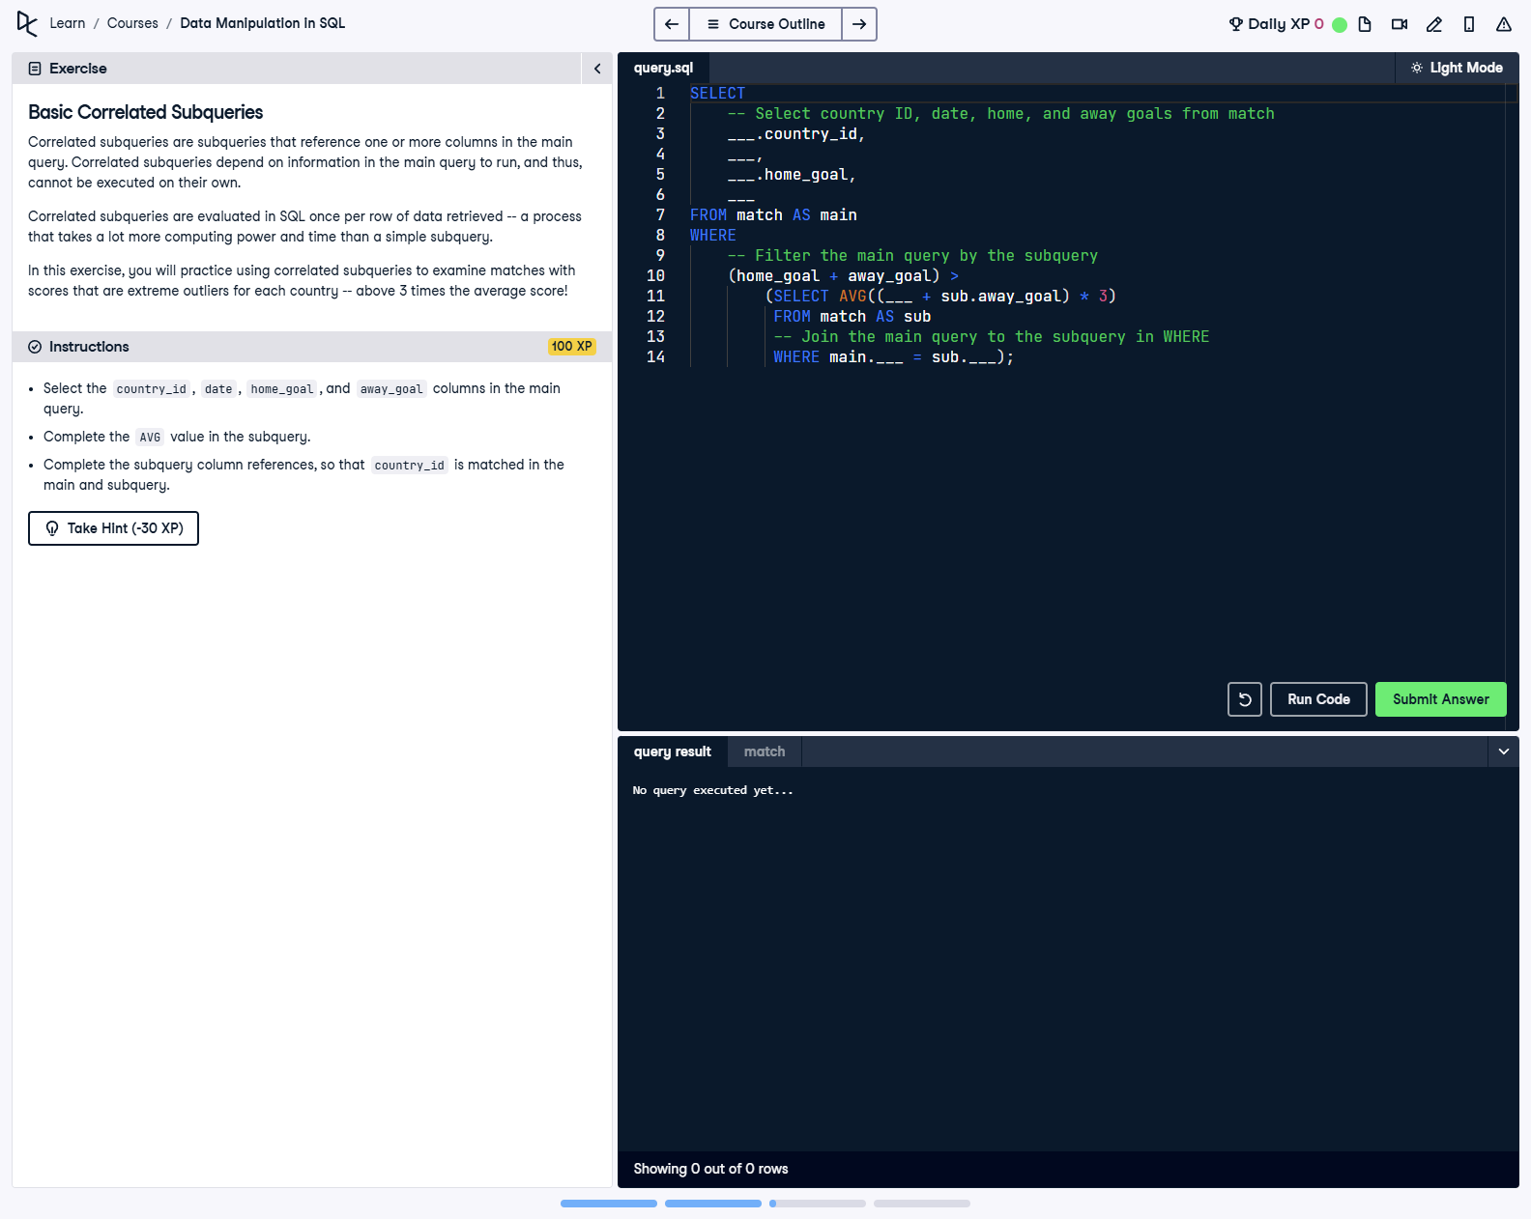

## Question

1. Select the country_id, date, home_goal, and away_goal columns in the main query.  
  
2. Complete the AVG value in the subquery.  
  
3. Complete the subquery column references, so that country_id is matched in the main and subquery.

## Corrected Solution

SELECT  
 -- Select country ID, date, home, and away goals from match  
 main.country_id,  
 main.date,  
 main.home_goal,  
 main.away_goal  
FROM match AS main  
WHERE  
 -- Filter the main query by the subquery  
 (main.home_goal + main.away_goal) >  
 (SELECT AVG(sub.home_goal + sub.away_goal) * 3  
 FROM match AS sub  
 WHERE main.country_id = sub.country_id);

## Explanation

This query identifies matches where the total goals scored (home + away goals) are extreme outliers, exceeding three times the average total goals for the respective country_id. The subquery calculates the average total goals for each country by matching the main query's country_id with the subquery's country_id. The WHERE clause in the main query filters for rows that meet this outlier criterion.